QUIRK & QUIRK, P.C.
ATTORNEYS AT LAW
450 BUCKHEAD CENTRE
2964 PEACHTREE ROAD, N.W.
ATLANTA, GEORGIA 30305-4903
Telephone Number
(404) 237-5595
JOSEPH P. FARRELL Facsimile Number
E-Mail Address: jpf@quirklaw.com (404) 237-7996

January 17, 2006

********
c/o ********
************
************

********
c/o ********
************
************

Re: Hidden Lake Academy. Inc. (the “School”) Dear Mr. *******:
This Firm represents Hidden Lake Academy. It has come to our attention that derogatory remarks have emanated from you regarding the School, its students and its staff In postings on the ww.fornits.com website, you falsely state that Bill Gray is an embezzler and an inbred and make perverted comments regarding his ex-wife and him personally. You also falsely state that Charles Cates is a monkey and implied that he made statements to your father just so that you would not be withdrawn from HLA. You make sick and perverse comments about Dr. Leonard Buccellato in addition to false and untrue statements about Hidden Lake Academy itself These statements represent just a few of the untrue and derogatory remarks you have made regarding the School, its students and its employees.

Those untrue remarks could potentially negatively affect the School’s work with its students and employees, thereby interfering with the business of Hidden Lake Academy. If you continue to make these kinds of remarks, the School will consider appropriate legal action including possible claims of libel and defamation. We demand that you immediately cease and desist making further negative and untrue comments about Hidden Lake Academy and any of its staff or employees. We also demand that you retract the remarks you have made in the forum. in which they were made.

PLEASE GOVERN YOURSELF ACCORDINGLY.
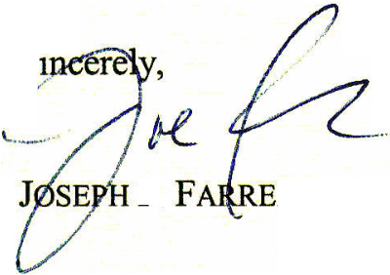
S.
LL
P.

